**Houman Alizadeh**

**Physics 300 Project**

**Global Optimization Techniques:**

The objective of global optimization is to find the globally best solution of (possibly nonlinear) models, in the (possible or known) presence of multiple local optima. Formally, global optimization seeks global solution(s) of a constrained optimization model.

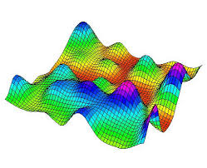

Source: https://webgol.dinfo.unifi.it/global-optimization-algorithms-in-python/

There are many different types of Global Optimization Techniques used in various fields, however we can categorize all of the methods into two general methods:

1. Deterministic Methods
2. Stochastic Methods

***Deterministic Global Optimization:***

Deterministic global optimization methods require ways to rigorously bound function values over regions of space. One could say that a main difference between deterministic and non-deterministic methods in this context is that the former perform calculations over regions of the solution space, whereas the latter perform calculations on single points. This is either done by exploiting particular functional forms, or using interval analysis in order to work with more general functional forms.

Deterministic Methods include:

* Inner and Outer Approximation,
* Cutting plane methods,
* Branch and bound methods,
* Interval methods

***Stochastic Global Optimization:***

Stochastic optimization (SO) methods are optimization methods that generate and use random variables. For stochastic problems, the random variables appear in the formulation of the optimization problem itself, which involve random objective functions or random constraints. Stochastic optimization methods also include methods with random iterates. Some stochastic optimization methods use random iterates to solve stochastic problems, combining both meanings of stochastic optimization. Stochastic optimization methods generalize deterministic methods for deterministic problems.

Stochastic Methods include:

* Direct Monte-Carlo sampling,
* Stochastic tunneling,
* Parallel tempering,
* Basin-Hopping

**Which method is better?**

Well this is not as easy question to answer, because each of the methods have their own perks. For example, Monte-Carlo can be used in physics-related problems for simulating systems with many coupled degrees of freedom, such as fluids, disordered materials, strongly coupled solids, and cellular structures. And basin hopping can be used to find the global minimum energy of a multiple atom Lennard-Jones Clusters. Therefore, we cannot choose the best technique for all applications because each method is built for a certain application. I will be demonstrating the Basin Hopping method for multiple atoms.

I will compare my results with the actual data of LJ clusters provided by Wales and Doyle in 1997.

**Basin Hopping Method**

Basin-hopping is a global optimization technique that iterates by performing random perturbation of coordinates, performing local optimization, and accepting or rejecting new coordinates based on a minimized function value. The algorithm was described in 1997 by David J. Wales and Jonathan Doye. This method is used mainly on finding the lowest energy for complex atomic interactions. It uses the Lennard-Jones potential of the system to calcualte the minima.

$$V=4ϵ\left[{\left(\frac{δ}{r}\right)}^{12}-{\left(\frac{δ}{r}\right)}^{6}\right]$$

Where ε= depth of the potential well, δ = finite distance at which the inner-particle potential is zero, and r = the distance between the particles.

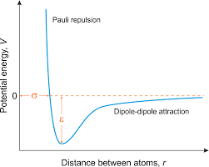

Source: <https://glossary.periodni.com/glossary.php?en=Lennard-Jones+potential>

Before we start our code, we have to make sure what our parameters are. In this case, since we are using basin hopping algorithm, we will have three variables such as:

1. Temperature
2. Step-size (distance between each iteration)
3. Number of Iterations

**Basin Hopping for 10 atoms:**

We will keep two of the parameters (Step-size and niter) constant for simplicity:

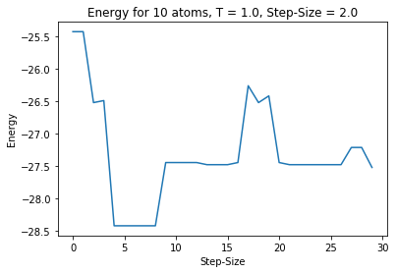

Figure 1- Energy vs Step-size for N=10: Global min found at step 5 as -28.4225

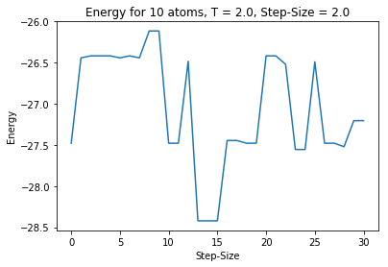

Figure 2- Energy vs Step-size for N=10: Global min found at step 15 as -28.4225

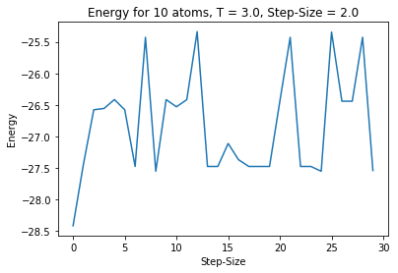

Figure 3- Energy vs Step-size for N=10: Global min found at step 0 as -28.4225

**Results:**

As we can see, when T = 1.0 (Figure 1), we got the global minimum at step 5, when T = 2.0 (Figure 2), we got the global minimum at step 15, and when T = 3.0 (Figure 3), we got the global minimum at step 0 which is very surprising and I think it only has to do with luck from the fact that we got the global minimum at step 0. From this trend, I can tell that as we increase the T parameter we will get the global minimum in less steps. However, putting temperature as 2.0 doesn’t really help as you can see. In this case putting T = 3.0 gave us the exact answer we were looking for in the shortest amount of iterations.

**Basin Hopping for 15 atoms:**

In this case we will put keep T and niter constant and will vary the Step-size to see the changes:

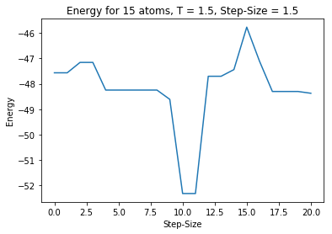

Figure 4- Energy vs Step-size for N=15: Global min found at step 10 as -52.3226

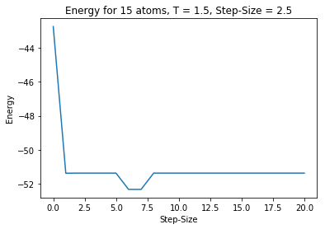

Figure 5- Energy vs Step-size for N=15: Global min found at step 6 as -52.3226

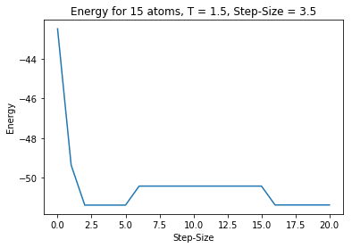

Figure 6- Energy vs Step-size for N=15: Global min not found

**Results:**

We kept T & niter constants and changed our Step-size. when Step-size = 1.5 (Figure 4), we got the global minimum at step 10, when Step-Size = 2.5 (Figure 5), we got the global minimum at step 6, and when Step-size = 3.5 (Figure 6), we were not given the actual global minimum which is -52.3226. It seems that keeping the Step-size around 2.0 gives us the best result. And increasing the Step-size above 3.0 gives us completely wrong global min. It is very crucial to not choose a big value for Step-size because sometimes the global minimum can be in between two very small gaps of numbers and if you choose the bigger Step-size, it will ignore the global minimum and will choose the closest local minimum. That’s exactly what happened in our last trial where we chose Step-size = 3.0 and it looks like we got stuck at local minimum = -51.3726 and we didn’t get the actual value of the global minimum.

**Basin Hopping for 12 atoms:**

Since changing niter won’t have too much effect on finding the global minimum. I will change all the parameters in each trial to find the best fit.

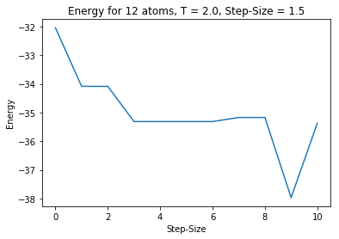

Figure 7- Energy vs Step-size for N=12: Global min found at step 9 as -37.9676

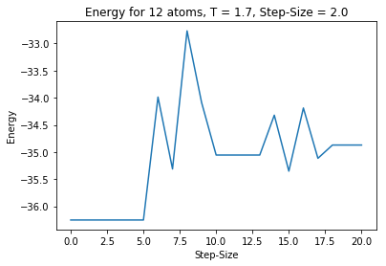

Figure 8- Energy vs Step-size for N=12: Global min not found

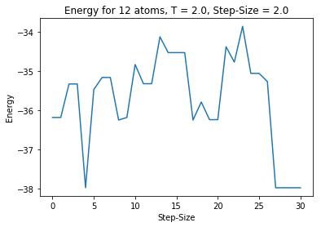

Figure 9- Energy vs Step-size for N=12: Global min found at step 4 as -37.9676

**Results:**

For N = 12, it was very difficult to find the global min. I found out that it's very important for T to be around 2.0, and Step-Size to be from 1.0 - 2.0 to get correct results. Of course, putting more iteration can be helpful too. For example, Figure 9 gives us the correct global min when we have T = 2.0 and Step-size = 2.0, and we get a completely wrong global min at Figure 8 when we change T = 1.7 and Step-Size = 2.0. So it’s very crucial to choose a correct temperature for 12 atom structures to get the correct global min.

**Note:** Keep in mind, I chose very small number of iterations due to quicker calculations. I definitely recommend choosing higher number for niter to get better results. Of course it’ll take more time to get the result with higher niter. Therefore, make sure to know the best fitted T and Step-size before choosing a high value for niter.

**Conclusion:**

This raps up our fun project of showing how basin hopping works and how it can be helpful to find the LJ clusters of different atomic structures. We discussed the importance of Global Optimization methods and gave an example of one of the most important methods in Global Optimization (Basin Hopping). As it is shown, Basin Hopping is one of the most crucial methods to find the lowest energy of atomic clusters that would be impossible solving without the code. I also showed that it’s very important to choose the best values with the three parameters to get the lowest energy possible. There are many other methods to use to find the best optimization and we briefly discussed some of them. If you are more interested, you can try the other methods to see the difference with Basin Hopping.

**References:**

* Global Optimization by Basin-Hopping and the Lowest Energy Structures of Lennard-Jones Clusters Containing up to 110 Atoms David J. Wales* and Jonathan P. K. Doye The Journal of Physical Chemistry A 1997 101 (28), 5111-5116 DOI: 10.1021/jp970984n
* Doye, J. P., & Wales, D. J. (1996). The Structure and Stability of Atomic Liquids: From Clusters to Bulk. Science, 271 (5248), 484-487. doi:10.1126/science.271.5248.484